**DAILY ONLINE ACTIVITIES SUMMARY**

|  |  |  |  |  |  |  |  |  |
| --- | --- | --- | --- | --- | --- | --- | --- | --- |
| **Date:** | **25 June 2020** | | | | | **Name:** | **K ISHA HEGDE** | |
| **Sem & Sec** | **4th sem, 2nd year** | | | | | **USN:** | **4al18cs031** | |
| **Online Test Summary** | | | | | | | | |
| **Subject** | | **---** | | | | | | |
| **Max. Marks** | | **----** | | **Score** | | | **---** | |
| **Certification Course Summary** | | | | | | | | |
| **Course** | **INTRODUCTION TO DIGITAL MARKETING** | | | | | | | |
| **Certificate Provider** | | | **GOOGLE GARAGE** | | **Duration** | | | **3.5 hours** |
| **Coding Challenges** | | | | | | | | |
| **Problem Statement:1 program** | | | | | | | | |
| **Status: Executed** | | | | | | | | |
| **Uploaded the report in Github** | | | | | **Yes** | | | |
| **If yes Repository name** | | | | | **<https://github.com/iishaii/locked-down_coding>** | | | |
| **Uploaded the report in slack** | | | | | **Yes** | | | |

#### *Certification Course Summary:*

Today I continued with INTRODUCTION TO DIGITAL MARKETING from google garage which is of 40 hrs. After the completion of course, certificate will be provided.

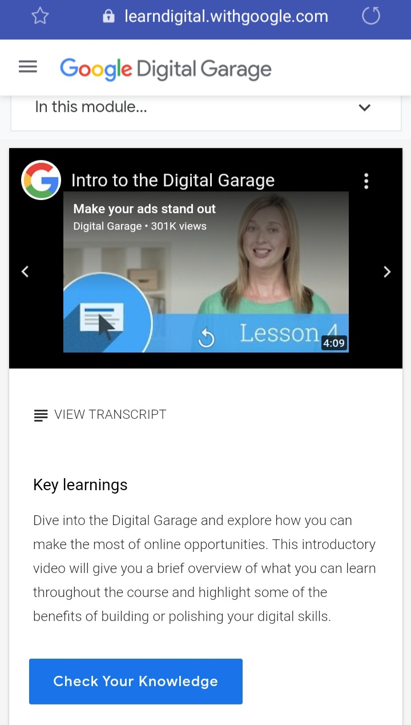

***Coding Challenges:***

Today I solved 1 coding challenge,

**1.Write a C Program to reverse the rows in a 2d Array**

Given a 2D array arr [][] of size M x N integers where M is the number of rows and N is the number of columns. The task is to reverse every row of the given 2D array.

**Example:**

**Input:** arr [][] =  
{ {1, 2, 3},  
{4, 5, 6},  
{7, 8, 9} }  
**Output:**  
3 2 1  
6 5 4  
9 8 7

**Input:** arr [][] =  
{ {1, 2},  
{4, 5},  
{7, 8},  
{9, 10} }  
**Output:**  
2 1  
5 4  
8 7  
10 9

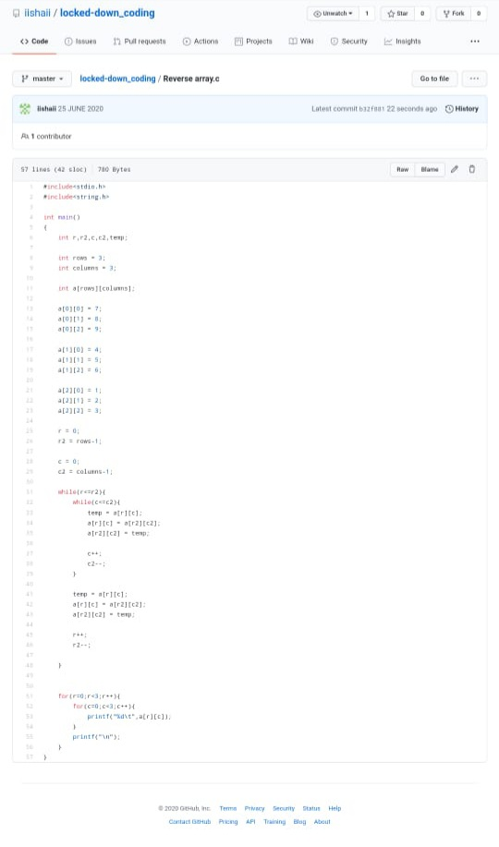

***Extra Activity:***

Today I attended Online training on C++ from 9:00-11:30 Am, Introduction to C++ and about different programs in the end attended Quiz for 10 min of 30 marks

